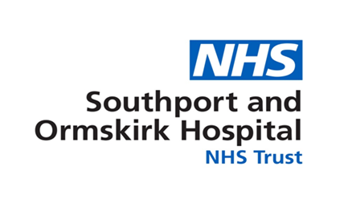
October 2021
Agenda Item |  |  |  |  |  | Report Title |  |  | Workforce Equality Monitoring 2020-21 Report
Executive Lead |  | Jane Royds: Director of Human Resources and OD
Lead Officer |  | Bob Davies: Equality Lead
Action Required  (Definitions below) |  |  | To Approve |  |  |  |  |  |  | To Note
 |  |  | To Assure |  |  |  |  |  |  | To Receive
 |  |  | For Information
Executive Summary
This report is published to ensure that Southport and Ormskirk Hospital NHS Trust has the information it needs to promote workforce equality and meet its public sector equality duty, as outlined in the Equality Act 2010.

The report details an analysis of the Southport and Ormskirk Hospital NHS Trust workforce for April 2020–March 2021.

Staff Profile Highlights
Headlines: As of March 2021, Southport and Ormskirk Hospital NHS Trust employed 3298 people of which:

- Gender: 78.26% of the workforce are Female and 21.74% are Male
- Age: 27.17% of the workforce are aged 35yrs and under, 47.79% of staff are 36yrs to 55yrs of age and 20.05% are aged over 55 years of age
- Ethnicity: The Trust workforce consists of 7.85% from Black Minority and Ethnic groups 81.72% White staff and 10.43% not stated unspecified prefer not to answer.
- Disability: 3.03% of the Workforce have disclosed that they consider themselves to have a Disability, 71.98% of staff have told us they don’t consider themselves to have a Disability with the remainder 24.98% either not declaring - other.
- Sexual Orientation: 82.2% of staff have disclosed their sexual orientation as Heterosexual or Straight, 1.33% as Lesbian or Gay, 0.58% Bisexual, 6.12% Not Stated and 9.76% Unspecified.
- Religion & Belief: religions & beliefs at the Trust are as follows 61.55% Christian, 9.16% Atheists, 2.03% Islam, 1.67% Hinduism, 4.06% Other Religions and 21.53% Unspecified or Not Disclosed.
- Employment Status: The workforce consists of 56.52% Full Time Staff and 43.48% Part time Staff
- Length of service: The highest proportion of the workforce have been employed by the Trust for between 1-5 years 30.50%, 15.77% of the workforce have been with the with the Trust for under 1 year and 3.79% of the Trust have been employed by the Trust for 30 years and above

Recommendation:
Workforce is asked to receive this report
 | Strategic Objective |  |  |  |  |  |  | Principal Risk
X | SO1 Improve clinical outcomes and patient safety to ensure we deliver high quality services |  |  |  |  | If quality is not maintained in line with regulatory standards this will impede clinical outcomes and patient safety.
 | SO2 Deliver services that meet NHS constitutional and regulatory standards |  |  |  |  | If the Trust cannot achieve its key performance targets it may lead to loss of services.
 | SO3 Efficiently and productively provide care within agreed financial limits |  |  |  |  | If the Trust cannot meet its financial regulatory standards and operate within agreed financial resources the sustainability of services will be in question.
X | SO4 Develop a flexible, responsive workforce of the right size and with the right skills who feel valued and motivated |  |  |  |  | If the Trust does not attract, develop, and retain a resilient and adaptable workforce with the right capabilities and capacity there will be an impact on clinical outcomes and patient experience.
X | SO5 Enable all staff to be patient-centred leaders building on an open and honest culture and the delivery of the Trust values |  |  |  |  | If the Trust does not have leadership at all levels patient and staff satisfaction will be impacted
 | SO6 Engage strategic partners to maximise the opportunities to design and deliver sustainable services for the population of Southport, Formby and West Lancashire |  |  |  |  | If the system does not have an agreed acute services strategy it may lead to non-alignment of partner organisations plans resulting in the inability to develop and deliver sustainable services
Linked to Regulation & Governance (the report supports …..)
CQC KLOEs |  |  |  |  |  | GOVERNANCE
X | Caring |  |  |  |  | X |  | Statutory Requirement
X | Effective |  |  |  |  |  |  | Annual Business Plan Priority
X | Responsive |  |  |  |  | X |  | Best Practice
X | Safe |  |  |  |  |  |  | Service Change
X | Well Led
Impact (is there an impact arising from the report on any of the following?)
 | Compliance |  |  |  | X |  |  | Legal
X | Engagement and Communication |  |  |  |  |  |  | Quality & Safety
X | Equality |  |  |  |  |  |  | Risk
 | Finance |  |  |  | X |  |  | Workforce
Equality Impact Assessment  If there is an impact on E&D, an Equality Impact Assessment must accompany the report) |  |  |  |  |  |  |  | Policy
 |  |  |  |  |  |  |  | Service Change
 |  |  |  |  |  |  |  | Strategy
Next Steps (List the required Actions and Leads following agreement by Committee)
The Workforce Equality Monitoring Report will be uploaded onto the Trust website to ensure the trust meets it obligation under the public sector equality duty, as outlined in the Equality Act 2010.
Previously Presented at:
 | Audit Committee |  |  |  |  |  | Quality & Safety Committee
 | Charitable Funds Committee |  |  |  |  |  | Remuneration & Nominations Committee
 | Finance, Performance & Investment Committee |  |  |  |  |  | Workforce Committee

Southport and Ormskirk Hospital NHS Trust Workforce Equality Monitoring Report April 2020 – March 2021

Executive Summary

Introduction
This report is published to ensure that Southport and Ormskirk Hospital NHS Trust has the information it needs to promote workforce equality and meet its public sector equality duty, as outlined in the Equality Act 2010.

The report details an analysis of the Southport and Ormskirk Hospital NHS Trust workforce for April 2020–March 2021. The challenges for the Trust in developing a diverse workforce is understanding the distinct differences in community make up across the area the Trust serves.

Staff Profile Highlights
Headlines: As of March 2021, Southport and Ormskirk Hospital NHS Trust employed 3298 people of which:

- Gender: 78.26% of the workforce are Female and 21.74% are Male
- Age: 27.17% of the workforce are aged 35yrs and under, 47.79% of staff are 36yrs to 55yrs of age and 20.05% are aged over 55 years of age
- Ethnicity: The Trust workforce consists of 7.85%% from Black Minority and Ethnic groups 81.72% White staff and 10.43% not stated unspecified prefer not to answer.
- Disability: 3.03% of the Workforce have disclosed that they consider themselves to have a Disability, 71.98% of staff have told us they don’t consider themselves to have a Disability with the remainder 24.98% either not declaring - other.
- Sexual Orientation: 82.2% of staff have disclosed their sexual orientation as Heterosexual or Straight, 1.33% as Lesbian or Gay, 0.58% Bisexual, 6.12% Not Stated and 9.76% Unspecified.
- Religion & Belief: religions & beliefs at the Trust are as follows 61.55% Christian, 9.16% Atheists, 2.03% Islam, 1.67% Hinduism, 4.06% Other Religions and 21.53% Unspecified or Not Disclosed.
- Employment Status: The workforce consists of 56.52% Full Time Staff and 43.48% Part time Staff
- Length of service: The highest proportion of the workforce have been employed by the Trust for between 1-5 years 30.50%, 15.77% of the workforce have been with the with the Trust for under 1 year and 3.79% of the Trust have been employed by the Trust for 30 years and above

Workforce data below provides a general overview of staff ethnicity, gender, religion and belief, sexual orientation, disability, employment status, length of service and recruitment.

Data figures in the various graphs are rounded up to the nearest point, the exact data figures are highlighted to the right of the graph.

Gender: 78.26% of the workforce is Female and 21.74% are Male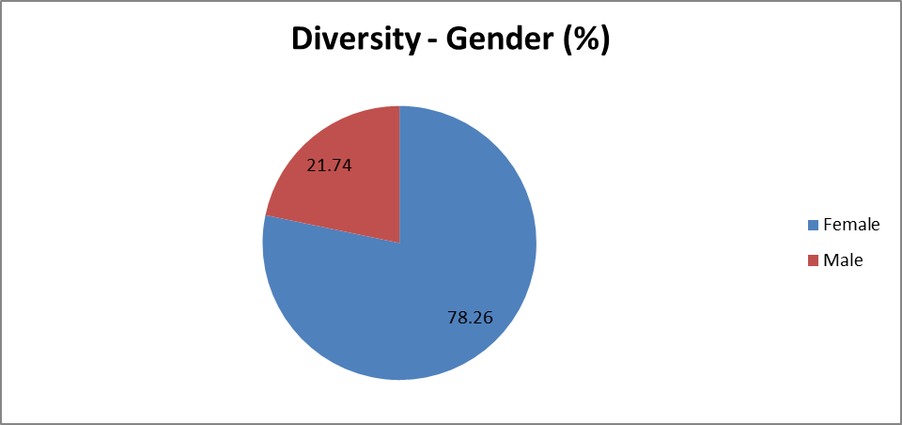

Age Profile: 27.17% of the workforce is aged 35yrs and under, 47.79% of staff are 36yrs to 55yrs of age and 25.05% are aged over 55 years of age 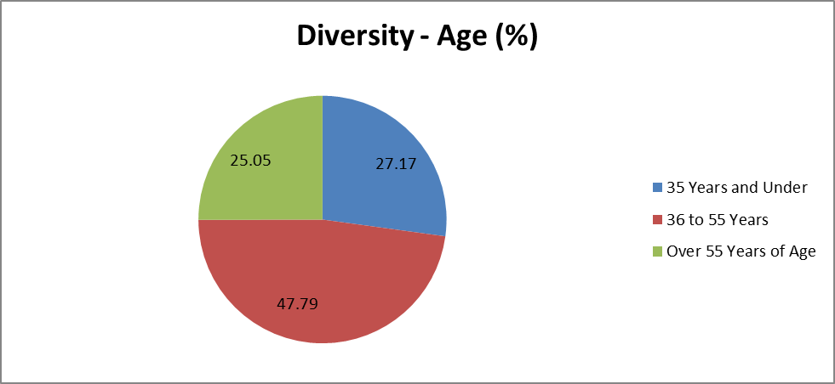

Ethnicity: The Trust workforce consists of 7.85% from Black Asian and Minority Ethnic groups 81.72% White staff and 10.43% Not Stated or Unspecified.
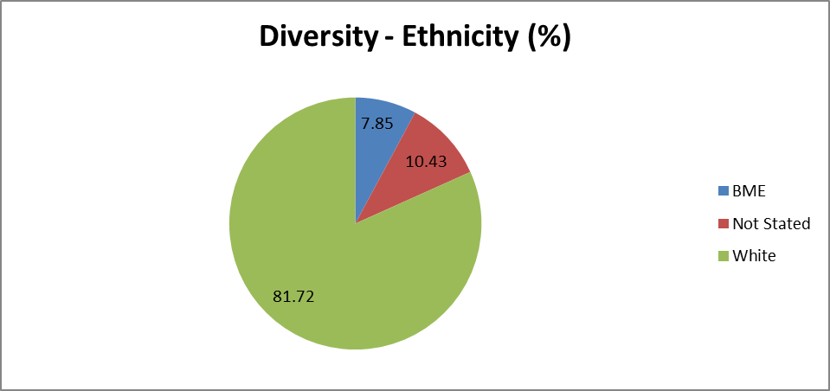

Ethnic Origin | Headcount | Percentage
A - White British | 2574 | 81.72% White staff (2,695)
B - White Irish | 24
C - Any Other White | 97 | 7.85% from Black Minority and Ethnic groups (259)
D - Mixed White/Black Caribbean | 8
E - Mixed White/Black African | 8
F - Mixed White/Asian | 7
G - Mixed Other | 10
H – Indian | 81
J – Pakistani | 24
K – Bangladeshi | 1
L - Other Asian | 50
M - Black Caribbean | 1
N - Black African | 21
P - Black Other | 7
R – Chinese | 5
S - Other Ethnic Group | 38
Not Stated / Unspecified | 344 | 10.43% Not Stated or Unspecified (344)
Grand Total | 3298

Disability: 3.03% of the Workforce informed the Trust that they consider themselves to have a disability, 71.98% of staff have told us they don’t consider themselves to have a disability with the remainder 24.98% either not declaring – other.
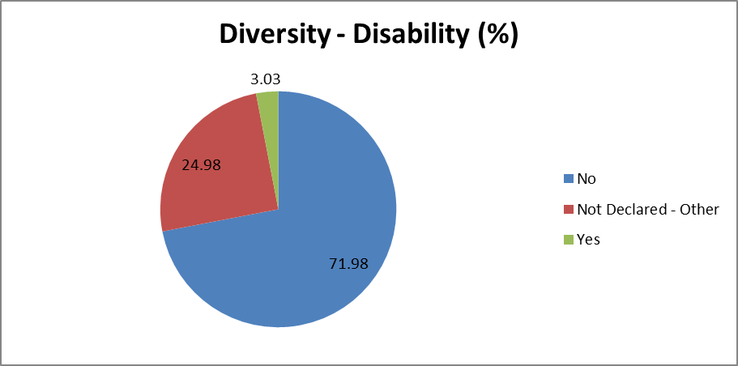

Disability | Headcount | Percentage %
No | 2374 | 71.98% of staff don’t consider themselves to have a disability
Not Declared - Other | 824 | 24.98% not disclosed
Yes | 100 | 3.03% of staff consider themselves to have a disability
Grand Total | 3298

Sexual Orientation: 82.2% of staff have disclosed their sexual orientation as Heterosexual or Straight, 1.33% as Lesbian or Gay, 0.58% Bisexual, 6.12% Not Stated and 9.76% Unspecified.
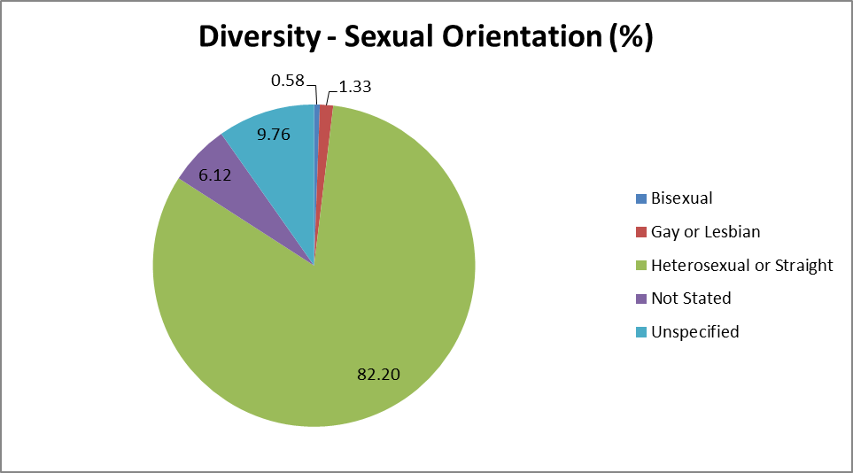

Sexual Orientation | Percentage %
Heterosexual or Straight | 82.2%
Lesbian or Gay | 1.33%
Bisexual | 0.58%
Not Stated | 6.12%
Unspecified | 9.76%

Religion & Belief: religions & beliefs at the Trust are as follows 61.55% Christian, 9.16% Atheists, 2.03% Islam, 1.67% Hinduism, 4.06% Other Religions and 21.53% Unspecified or Not Disclosed.
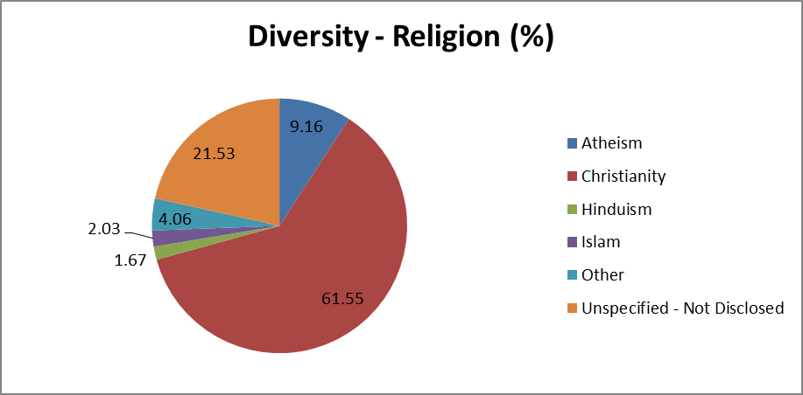

Religion & Belief | Percentage %
Christian | 61.55%
Atheists | 9.16%
Islam | 2.03%
Hinduism | 1.67%
Other Religions | 4.06%
Unspecified or Not Disclosed | 21.53%

Employment Status: The workforce consists of 56.52% Full Time Staff and 43.48% Part time Staff
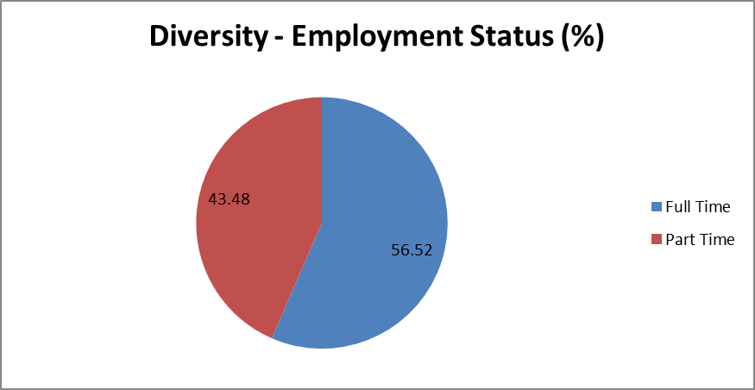

Employee Category | Female% | Male %
Fulltime | 38.81% | 17.71
Part Time | 39.45% | 4.03
Grand Total Workforce % | 78.26% | 21.74%

Length of service: The highest proportion of the workforce have been employed by the Trust for between 1-5 years 30.50%, 15.77% of the workforce have been with the with the Trust for under 1 year and 3.79% of the Trust have been employed by the Trust for 30 years and above
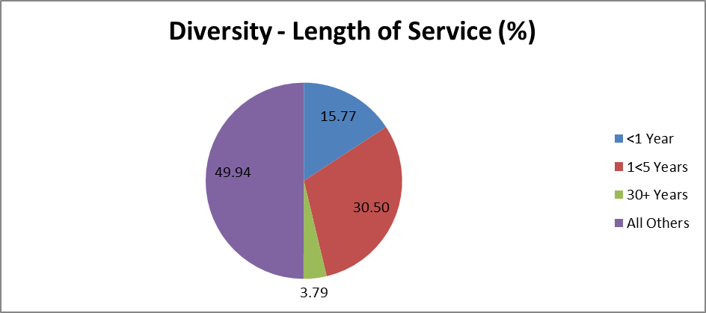

Length of Service Band | Percentage of Staff in Age Bands
<1 Year | 15.77%
1<5 Years | 30.50%
5<10 Years | 17.62%
10<15 Years | 10.40%
15<20 Years | 12.25%
20<25 Years | 6.19%
25<30 Years | 3.49%
30+ Years | 3.79%

Workforce Race Equality Standard (WRES) & Workforce Disability Equality Standard (WDES)
The Trust completes the annual WRES & WDES reports, the aim of the WRES and WDES is to ensure employees from black and minority ethnic (BME) backgrounds and staff with a disability / long-term conditions have equal access to career opportunities and receive fair treatment in the workplace. The WRES and WDES reports consist of information from the NHS Staff Survey, ESR and TRAC.

Conclusion
The Southport and Ormskirk Hospital NHS Trust Staff Equality Monitoring Report ,April 2020 – March 2021 update, completed by the Trust highlights the Trusts commitment to providing information on the make-up of its workforce, The Trust recognises the importance of having a workforce that is representative of the diverse communities the Trust serves and aims by working in partnership with our staff and partners from the diverse communities to make sure that any gaps and inequalities are identified and addressed.

Recommended Actions
Southport & Ormskirk Hospital NHS Trust People Plan
The diversity of our workforce is a key indicator of an inclusive culture. The effectiveness of line managers and their teams in setting the right cultural and behavioural tone by celebrating difference, empowering others to make their own unique contribution, and actively listening and then taking supported action cannot be understated.

As a progressive and inclusive Trust, we will regularly review key workforce information as a commitment to continuously improving and strengthening our community and be accountable for the commitments we have made.

The Trust will ensure key findings of the Workforce Equality Monitoring Report 2020-21 are referenced within the relevant sections of the evidence being provided for NHS Equality Delivery System 2 (EDS2)

The Trust will monitor progress on the Trust Workforce Race & Disability Equality Standard and Gender Pay Gap Report action plans 2020-21 and will submit updates to the relevant Trust groups and committees, updates will also be provided to the Sefton CCG Equality and Diversity lead as part of the equality & diversity section of the quality contract.

The Trust will publish the Workforce Equality Monitoring Report April 2020 – March 2021 the Workforce Disability Equality Standard (WDES) Report 2020-21 and the Workforce Race Equality Standard (WRES) Report 2020-21 on the Trust website to ensure the Trust is compliant.

