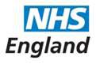

Open and Honest Care in your Local Hospital



***The Open and Honest Care:* Driving Improvement programme aims to support organisations to become more transparent and consistent in publishing safety, experience and improvement data, with overall aim of improving care, practice and culture**

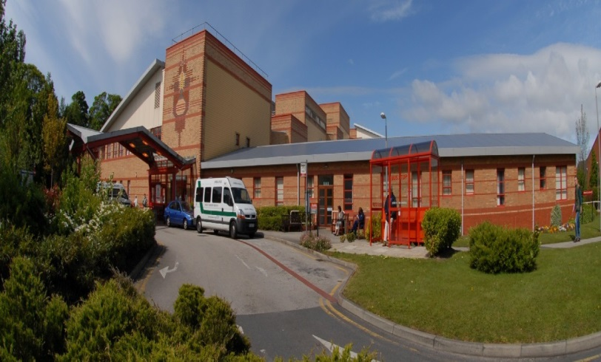

Report for:

**Southport & Ormskirk Hospital NHS Trust**

November 2019

This report is based on information from September 2019. The information is presented in three key categories: safety, experience and improvement. These reports will also signpost you towards additional information about Southport & Ormskirk Hospital NHS Trust (SOHT) performance.

**1. SAFETY**

**Safety Thermometer**

The NHS Safety Thermometer is used nationally but is designed to be a local improvement tool for measuring, monitoring, and analysing patient harms and developing systems that then provide 'harm free' care. The NHS Safety Thermometer has been designed to be used by frontline healthcare professionals to measure a ‘snapshot’ of harm once a month from pressure ulcers, falls with harm, urinary infection in patients with catheters (CAUTI) and treatment for blood clots (VTE). These harms are measured in two ways, harms which are old and sustained prior to admission and new harms which occurred whilst the patient was in hospital. The data is used alongside other outcome measures to help us understand themes, analysis findings and plan improvements in care delivery.

The score below show the percentage of patients who received harm free care whilst an inpatient.

**97.71%** of patients did not experience any of the four harms

In September 2019, SOHT achieved 97.71% harm free care, with 2.29% of patients on the day recorded in the category of ‘new’ harm (sustained whilst they were in our care). Broken down into the four categories this equated to 1 fall with low harm, 0 VTE, 4 CAUTI and no incidents of pressure ulcer development of category 2 or above.

Progress is monitored through the Trusts Quality & Safety Committee

For more information, including a breakdown by category, please visit: <http://www.safetythermometer.nhs.uk>

**Health Care Associated Infections (HCAIs)**

HCAIs are infections acquired as a result of healthcare interventions. Clostridium difficile (C. difficile) and methicillin-resistant staphylococcus aureus (MRSA) bacteremia are nationally monitored as we are trying to reduce the incidence of these infections. C. difficile is a type of bacterial infection that can affect the digestive system, causing diarrhoea, fever and painful abdominal cramps - and sometimes more serious complications. The bacteria do not normally affect healthy people, but because some antibiotics remove the 'good bacteria' in the gut that protect against C.difficile, people on these antibiotics are at greater risk.

The MRSA bacteria are often carried on the skin and inside the nose and throat. It is a particular problem in hospitals because if it gets into a break in the skin it can cause serious infections and blood poisoning. It is also more difficult to treat than other bacterial infections as it is resistant to a number of widely-used antibiotics.

We have a zero tolerance policy to MRSA bacteraemia infections and are working towards reducing C Difficile infections; part of this process is to set improvement targets. If the number of actual cases is greater than the target then we have not improved enough.

The table below shows the number of infections we have had this month plus the improvement target which has been set for us by the National Health Service Improvement (NHSi) Agency and results for the year to date. The Trust also sets its own ‘internal stretch’ targets as a way of improving ourselves even further.

|  |  |  |
| --- | --- | --- |
|  | **C. difficile** | **MRSA** |
| **September 2019** | **1** | **0** |
| Annual improvement target | 16 | 0 |
| Actual year to date | 14 | 1 |

Each incident of infection is reviewed and a thematic analysis undertaken. This is monitored through the Trusts Quality & Safety Committee

**Pressure Ulcers**

Pressure ulcers are localised injuries to the skin and/or underlying tissue as a result of pressure. They are sometimes known as bedsores. They can be classified into four categories, with one being the least severe and four being the most severe. The pressure ulcers reported include all validated avoidable / unavoidable pressure ulcers that were obtained at any time during a hospital admission that were not present on initial assessment.

The pressure ulcer numbers include all pressure ulcers that occurred from 72 hours after admission to this Trust

|  |  |  |
| --- | --- | --- |
| **September 2019** | 4 | Category 2 to category 4 pressure ulcers that were acquired during hospital stays |

|  |  |
| --- | --- |
| **Severity** | **Number of Pressure Ulcers** |
| Category 2 | 3 |
| Category 3 | 1 |
| Category 4 | 0 |

So we can know if we are improving, even if the number of patients we are caring for goes up or down, we also calculate an average called 'rate per 1,000 occupied bed days'. This allows us to compare our improvement over time, but cannot be used to compare us with other hospitals, as their staff may report pressure ulcers in different ways, and their patients may be more or less vulnerable to developing pressure ulcers than our patients. For example, other hospitals may have younger or older patient populations, who are more or less mobile, or are undergoing treatment for different illnesses.

|  |  |
| --- | --- |
| Rate per 1,000 occupied bed days | 0.34 |

**Falls**

This measure includes all falls in the hospital that resulted in injury, categorised as moderate, severe or death, regardless of cause. This includes avoidable and unavoidable falls sustained at any time during the hospital admission.

|  |  |  |
| --- | --- | --- |
| September 2019 | 1 | Falls that caused at least moderate’ harm |

In order to know if we are improving even if the number of patients we are caring for goes up or down, we also calculate an average called ‘rate per 1,000 occupied bed days’. This allows us to compare our improvement over time, but cannot be used to compare us to other hospitals, as their staff may report falls in different ways, and their patients may be more or less vulnerable to falling than our patients. For example, other hospitals may have younger or older patient populations, who are more or less mobile, or are undergoing treatment for different illnesses.

|  |  |
| --- | --- |
| Rate per 1,000 occupied bed days | 5.44 |

**Safe Staffing**

In 2014 NHS England and the CQC launched ‘Hard Truths Commitment’. This work complimented the National Quality Board guidance to optimise nursing and midwifery staffing capacity and capability. Each month the

Trust will publish data that demonstrates the planned versus actual number of staff on each shift for each day of the month. The Hard Truths data will be available on the Trust website & NHS Choices for the public to see. The data is presented in a format that is user/public ‘friendly’ and supported by a narrative to enable an understanding of the information provided.

The Trust Safer Staffing numbers are reported as part of the Public Trust Board papers, accessible via the following link:  [SOHT Trust Board Agendas and Papers](https://www.southportandormskirk.nhs.uk/downloads.asp?dir=c%3A%5CWebsite%5Cdownloads%5CTrust+Board%5CAgendas)

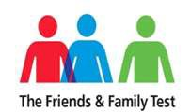**2. EXPERIENCE**

To measure patient and staff experience we ask a number of questions. The idea is simple: if you like using a certain product or doing business with a particular company you like to share this experience with others.

The answers given are used to give a score which is the percentage of patients who responded that they would recommend our service to their friends and family

**Patient Experience**

**The Friends and Family Test**

The Friends and Family Test (FFT) requires all patients to be asked, at periodic points or following discharge, **‘*How likely are you to recommend our ward /A&E /service /organisation to friends and family if they needed similar care or treatment?’***

**September 2019**

|  |  |  |
| --- | --- | --- |
| **Clinical location** | **Number of responders** | **% who would recommend** |
| **Inpatient wards (inc. children’s ward)** | 461 | 92.56 % |
| **A&E (SOHT only)** | 107 | 70.09% |
| **Maternity** | 103 | 97.09 % |
| **Overall Trust \***  **Also includes Children’s A&E)** | 628 | 88.85% |

*This result may have changed since publication, for the latest score please visit:

[Southport & Formby District General Hospital](https://www.nhs.uk/Services/hospitals/Overview/DefaultView.aspx?id=1412)

Ormskirk & District General Hospital

**3. IMPROVEMENT**

**Improvement story: we are listening to our patients and making changes**

**CRADLE launches early pregnancy loss service at Ormskirk hospital**

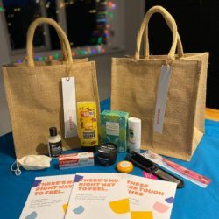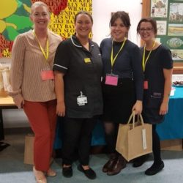

Cradle, a charity which provides early pregnancy loss support, so that they can continue to care for bereaved parents for baby loss, has launched its service at Ormskirk hospital.

Thanks to Cradle, women and their partners or companions receiving emergency care for early pregnancy loss will now receive a comfort bag. Each bag contains practical and beautiful things; however the most important item in the bag is the letter ‘Dear Friend’. The letter will signpost women to support provided by Cradle ambassadors, who themselves have experienced early pregnancy loss.

Cradle was founded by Louise Zeniou, who had an ectopic pregnancy in 2015. Cradle is now supported by a national team of early pregnancy loss ambassadors, all of whom have experienced ectopic pregnancy, miscarriage, missed miscarriage, molar pregnancy or compassionate induction.

Lynne Eastham, head of midwifery and nursing explains: “This is a fantastic idea and we are delighted that Louise has chosen to launch this national project at Ormskirk hospital, where she was in our care in 2015.

“Early pregnancy loss is often not discussed and families may not share this news with their wider family or friends, due to the social convention of not announcing pregnancy until after 12 weeks. As a result, people are sometimes less comfortable with asking for help or discussing their feelings. Thank you to everyone at Cradle for giving their time to help these families in need.”

Louise Zeniou explains: “I have worked with the healthcare team at Ormskirk since January 2019 and together we developed a bespoke service to support bereaved parents during and following early pregnancy loss. The project has grown and we now have a national team of early pregnancy loss ambassadors who are bringing Cradle to their own local NHS trusts. I will continue to work with Ormskirk and will be developing an early pregnancy loss football team and other community grief projects for anyone affected by the loss of a baby.”