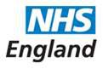

Open and Honest Care in your Local Hospital



***The Open and Honest Care:* Driving Improvement programme aims to support organisations to become more transparent and consistent in publishing safety, experience and improvement data, with overall aim of improving care, practice and culture**

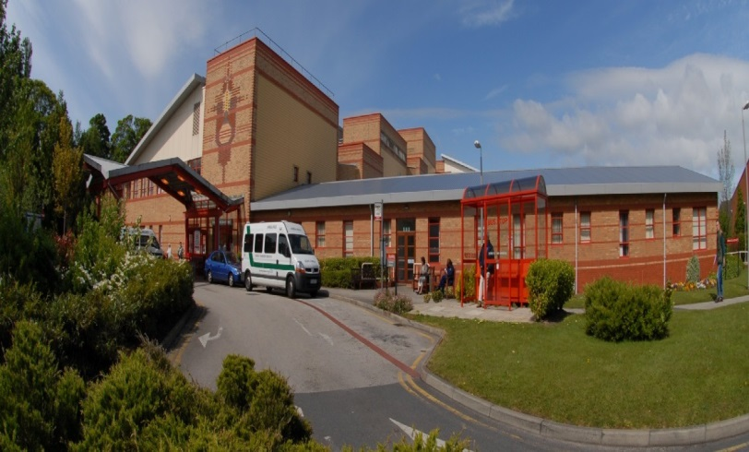

Report for:

**Southport & Ormskirk Hospital NHS Trust**

July 2019

This report is based on information from May 2019. The information is presented in three key categories: safety, experience and improvement. These reports will also signpost you towards additional information about Southport & Ormskirk Hospital NHS Trust (SOHT) performance.

**1. SAFETY**

**Safety Thermometer**

The NHS Safety Thermometer is used nationally but is designed to be a local improvement tool for measuring, monitoring, and analysing patient harms and developing systems that then provide 'harm free' care. The NHS Safety Thermometer has been designed to be used by frontline healthcare professionals to measure a ‘snapshot’ of harm once a month from pressure ulcers, falls with harm, urinary infection in patients with catheters (CAUTI) and treatment for blood clots (VTE). These harms are measured in two ways, harms which are old and sustained prior to admission and new harms which occurred whilst the patient was in hospital. The data is used alongside other outcome measures to help us understand themes, analysis findings and plan improvements in care delivery.

The score below show the percentage of patients who received harm free care whilst an inpatient.

**96.29%** of patients did not experience any of the four harms

In May 2019, SOHT achieved 96.29% harm free care, with 3.71% of patients on the day recorded in the category of ‘new’ harm (sustained whilst they were in our care). Broken down into the four categories this equated to 2 patient falls with harm, 3 patient VTE, 4 patients with CAUTI and 3 patients with incidents of pressure ulcer development of grade 2 or above.

Progress is monitored through the Trusts Quality & Safety Committee

For more information, including a breakdown by category, please visit: <http://www.safetythermometer.nhs.uk>

**Health Care Associated Infections (HCAIs)**

HCAIs are infections acquired as a result of healthcare interventions. Clostridium difficile (C. difficile) and methicillin-resistant staphylococcus aureus (MRSA) bacteremia are nationally monitored as we are trying to reduce the incidence of these infections. C. difficile is a type of bacterial infection that can affect the digestive system, causing diarrhoea, fever and painful abdominal cramps - and sometimes more serious complications. The bacteria do not normally affect healthy people, but because some antibiotics remove the 'good bacteria' in the gut that protect against C.difficile, people on these antibiotics are at greater risk.

The MRSA bacteria are often carried on the skin and inside the nose and throat. It is a particular problem in hospitals because if it gets into a break in the skin it can cause serious infections and blood poisoning. It is also more difficult to treat than other bacterial infections as it is resistant to a number of widely-used antibiotics.

We have a zero tolerance policy to MRSA bacteraemia infections and are working towards reducing C Difficile infections; part of this process is to set improvement targets. If the number of actual cases is greater than the target then we have not improved enough.

The table below shows the number of infections we have had this month plus the improvement target which has been set for us by the National Health Service Improvement (NHSi) Agency and results for the year to date. The Trust also sets its own ‘internal stretch’ targets as a way of improving ourselves even further.

|  |  |  |
| --- | --- | --- |
|  | **C. difficile** | **MRSA** |
| **May 2019** | **0** | **0** |
| Annual improvement target | 16 | 0 |
| Actual year to date | 5 | 0 |

Each incident of infection is reviewed and a thematic analysis undertaken. This is monitored through the Trusts Quality & Safety Committee

**Pressure Ulcers**

Pressure ulcers are localised injuries to the skin and/or underlying tissue as a result of pressure. They are sometimes known as bedsores. They can be classified into four categories, with one being the least severe and four being the most severe. The pressure ulcers reported include all validated avoidable / unavoidable pressure ulcers that were obtained at any time during a hospital admission that were not present on initial assessment.

The pressure ulcer numbers include all pressure ulcers that occurred from 72 hours after admission to this Trust.

|  |  |  |
| --- | --- | --- |
| **May 2019** | 12 | Category 2 to category 4 pressure ulcers that were acquired during hospital stays |

|  |  |
| --- | --- |
| **Severity** | **Number of Pressure Ulcers** |
| Category 2 | 11 |
| Category 3 | 1 |
| Category 4 | 0 |

So we can know if we are improving, even if the number of patients we are caring for goes up or down, we also calculate an average called 'rate per 1,000 occupied bed days'. This allows us to compare our improvement over time, but cannot be used to compare us with other hospitals, as their staff may report pressure ulcers in different ways, and their patients may be more or less vulnerable to developing pressure ulcers than our patients. For example, other hospitals may have younger or older patient populations, who are more or less mobile, or are undergoing treatment for different illnesses.

|  |  |
| --- | --- |
| Rate per 1,000 occupied bed days | 0.89 |

**Falls**

This measure includes all falls in the hospital that resulted in injury, categorised as moderate, severe or death, regardless of cause. This includes avoidable and unavoidable falls sustained at any time during the hospital admission.

|  |  |  |
| --- | --- | --- |
| May 2019 | 2 | Falls that caused at least ‘moderate’ harm |

In order to know if we are improving even if the number of patients we are caring for goes up or down, we also calculate an average called ‘rate per 1,000 occupied bed days’. This allows us to compare our improvement over time, but cannot be used to compare us to other hospitals, as their staff may report falls in different ways, and their patients may be more or less vulnerable to falling than our patients. For example, other hospitals may have younger or older patient populations, who are more or less mobile, or are undergoing treatment for different illnesses.

|  |  |
| --- | --- |
| Rate per 1,000 occupied bed days | 5.19 |

**Safe Staffing**

In 2014 NHS England and the CQC launched ‘Hard Truths Commitment’. This work complimented the National Quality Board guidance to optimise nursing and midwifery staffing capacity and capability. Each month the

Trust will publish data that demonstrates the planned versus actual number of staff on each shift for each day of the month. The Hard Truths data will be available on the Trust website & NHS Choices for the public to see. The data is presented in a format that is user/public ‘friendly’ and supported by a narrative to enable an understanding of the information provided.

The Trust Safer Staffing numbers are reported as part of the Public Trust Board papers, accessible via the following link:  [SOHT Trust Board Agendas and Papers](https://www.southportandormskirk.nhs.uk/downloads.asp?dir=c%3A%5CWebsite%5Cdownloads%5CTrust+Board%5CAgendas)

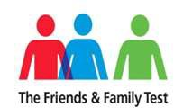**2. EXPERIENCE**

To measure patient and staff experience we ask a number of questions. The idea is simple: if you like using a certain product or doing business with a particular company you like to share this experience with others.

The answers given are used to give a score which is the percentage of patients who responded that they would recommend our service to their friends and family

**Patient Experience**

**The Friends and Family Test**

The Friends and Family Test (FFT) requires all patients to be asked, at periodic points or following discharge, **‘*How likely are you to recommend our ward /A&E /service /organisation to friends and family if they needed similar care or treatment?’***

**May 2019**

|  |  |  |
| --- | --- | --- |
| **Clinical location** | **Number of responders** | **% who would recommend** |
| **Inpatient wards (inc. children’s ward)** | 493 | 96.15 % |
| **A&E (SOHT only)** | 21 | 80.95 % |
| **Maternity** | 67 | 92.54 % |
| **Overall Trust \***  **Also includes Children’s A&E)** | 637 | 95.29% |

*This result may have changed since publication, for the latest score please visit:

[Southport & Formby District General Hospital](https://www.nhs.uk/Services/hospitals/Overview/DefaultView.aspx?id=1412)

[Ormskirk & District General Hospital](https://www.nhs.uk/Services/hospitals/Overview/DefaultView.aspx?id=886)

**3. IMPROVEMENT**

**Improvement story: we are listening to our patients and making changes**

**Visit by Professor Brian Dolan**

Prof Brian Dolan OBE who is the originator of the #Last1000days and #EndPJparalysis projects recently visited the Trust as a way of sharing the work he has pioneered around the world in respect of maximising time for those patients who may be in the last 1000 days of their life, as well as encouraging patients to get up, get dressed and move about whilst in hospital. His visit was both inspirational and motivational for all disciplines of clinical staff and a challenge that staff are more than happy to engage with.

He spoke to more than 100 people in his talks and even more during a walk around at both hospital sites.  His main points were:

* Time is the most important currency in healthcare. Staff time is precious, patient time is sacred. We must not waste time
* "Safe" has become one of the most dangerous words in healthcare. We must consider the risk of doing as well as the risk of not doing something - and enable people to make informed choices about their care and treatment
* We must do everything we can return people do their own homes, if that is their wish. We are not at liberty to deprive people of this
* The standards and practices we participate in delivering or observing are the standards and practices we professionally accept. We must be proud to raise the bar now collectively and call out good and poor practice
* We are in a journey as a big team. It is an uphill climb but we must make decisions based on doing the right thing for patients, carers and staff. This will empower and build a positive and great place to work and receive care. Everyone is here for the same reason, and has the ability to thrive and empower others to thrive too, we must support each other.

The [#EndPJparalysis](https://nhs.us14.list-manage.com/track/click?u=5db5c4624dcd9d02cc1ea9033&id=7db0af4793&e=85d6eee02c) global summit takes place on 10-12th July and staff are looking at ways of actively engaging with this project at ward level with lots planning to get staff in pyjamas, get all patients dressed, create leaflets and posters.