

Open and Honest Care in your Local Hospital



***The Open and Honest Care:* Driving Improvement programme aims to support organisations to become more transparent and consistent in publishing safety, experience and improvement data, with overall aim of improving care, practice and culture**

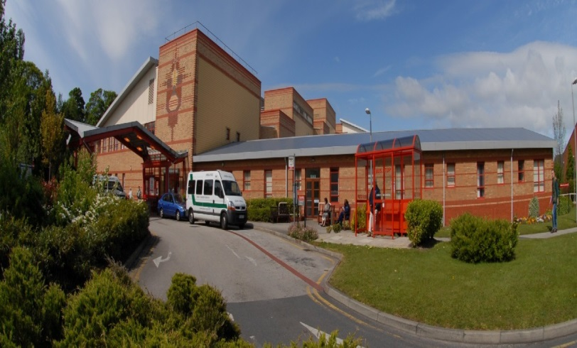

Report for:

**Southport & Ormskirk Hospital NHS Trust**

February 2019

This report is based on information from January 2019. The information is presented in three key categories: safety, experience and improvement. These reports will also signpost you towards additional information about Southport & Ormskirk Hospital NHS Trust (SOHT) performance.

**1. SAFETY**

**Safety Thermometer**

The NHS Safety Thermometer is used nationally but is designed to be a local improvement tool for measuring, monitoring, and analysing patient harms and developing systems that then provide 'harm free' care. The NHS Safety Thermometer has been designed to be used by frontline healthcare professionals to measure a ‘snapshot’ of harm once a month from pressure ulcers, falls with harm, urinary infection in patients with catheters (CAUTI) and treatment for blood clots (VTE). These harms are measured in two ways, harms which are old and sustained prior to admission and new harms which occurred whilst the patient was in hospital. The data is used alongside other outcome measures to help us understand themes, analysis findings and plan improvements in care delivery.

The score below show the percentage of patients who received harm free care whilst an inpatient.

**98.25%** of patients did not experience any of the four harms

In January 2019, SOHT achieved 98.25% harm free care, with 1.75% of patients on the day recorded in the category of ‘new’ harm (sustained whilst they were in our care). Broken down into the four categories this equated to 2 x falls with harm, 1 x VTE, 1 x CAUTI and 3 x incidents of pressure ulcer development of grade 2.

Progress is monitored through the Trusts Quality & Safety Committee

For more information, including a breakdown by category, please visit: <http://www.safetythermometer.nhs.uk>

**Health Care Associated Infections (HCAIs)**

HCAIs are infections acquired as a result of healthcare interventions. Clostridium difficile (C. difficile) and methicillin-resistant staphylococcus aureus (MRSA) bacteremia are nationally monitored as we are trying to reduce the incidence of these infections. C. difficile is a type of bacterial infection that can affect the digestive system, causing diarrhoea, fever and painful abdominal cramps - and sometimes more serious complications. The bacteria do not normally affect healthy people, but because some antibiotics remove the 'good bacteria' in the gut that protect against C.difficile, people on these antibiotics are at greater risk.

The MRSA bacteria are often carried on the skin and inside the nose and throat. It is a particular problem in hospitals because if it gets into a break in the skin it can cause serious infections and blood poisoning. It is also more difficult to treat than other bacterial infections as it is resistant to a number of widely-used antibiotics.

We have a zero tolerance policy to MRSA bacteraemia infections and are working towards reducing C Difficile infections; part of this process is to set improvement targets. If the number of actual cases is greater than the target then we have not improved enough.

The table below shows the number of infections we have had this month plus the improvement target which has been set for us by the National Health Service Improvement (NHSi) Agency and results for the year to date. The Trust also sets its own ‘internal stretch’ targets as a way of improving ourselves even further.

|  |  |  |
| --- | --- | --- |
|  | **C. difficile** | **MRSA** |
| **January 2019** | **0** | **0** |
| Annual improvement target | 35 | 0 |
| Actual year to date | 8 | 0 |

Each incident of infection is reviewed and a thematic analysis undertaken. This is monitored through the Trusts Quality & Safety Committee

**Pressure Ulcers**

Pressure ulcers are localised injuries to the skin and/or underlying tissue as a result of pressure. They are sometimes known as bedsores. They can be classified into four categories, with one being the least severe and four being the most severe. The pressure ulcers reported include all validated avoidable / unavoidable pressure ulcers that were obtained at any time during a hospital admission that were not present on initial assessment.

The pressure ulcer numbers include all pressure ulcers that occurred from 72 hours after admission to this Trust

|  |  |  |
| --- | --- | --- |
| **January**  **2019** | 9 | Category 2 to category 4 pressure ulcers that were acquired during hospital stays |

|  |  |
| --- | --- |
| **Severity** | **Number of Pressure Ulcers** |
| Category 2 | 8 |
| Category 3 | 1 |
| Category 4 | 0 |

So we can know if we are improving, even if the number of patients we are caring for goes up or down, we also calculate an average called 'rate per 1,000 occupied bed days'. This allows us to compare our improvement over time, but cannot be used to compare us with other hospitals, as their staff may report pressure ulcers in different ways, and their patients may be more or less vulnerable to developing pressure ulcers than our patients. For example, other hospitals may have younger or older patient populations, who are more or less mobile, or are undergoing treatment for different illnesses.

|  |  |
| --- | --- |
| Rate per 1,000 occupied bed days | 0.66 |

**Falls**

This measure includes all falls in the hospital that resulted in injury, categorised as moderate, severe or death, regardless of cause. This includes avoidable and unavoidable falls sustained at any time during the hospital admission.

|  |  |  |
| --- | --- | --- |
| January 2019 | 2 | Falls that caused at least moderate’ harm |

In order to know if we are improving even if the number of patients we are caring for goes up or down, we also calculate an average called ‘rate per 1,000 occupied bed days’. This allows us to compare our improvement over time, but cannot be used to compare us to other hospitals, as their staff may report falls in different ways, and their patients may be more or less vulnerable to falling than our patients. For example, other hospitals may have younger or older patient populations, who are more or less mobile, or are undergoing treatment for different illnesses.

|  |  |
| --- | --- |
| Rate per 1,000 occupied bed days | 6.65 |

**Safe Staffing**

In 2014 NHS England and the CQC launched ‘Hard Truths Commitment’. This work complimented the National Quality Board guidance to optimize nursing and midwifery staffing capacity and capability. Each month the Trust will publish data that demonstrates the planned versus actual number of staff on each shift for each day of the month. The Hard Truths data will be available on the Trust website & NHS Choices for the public to see. The data is presented in a format that is user/public ‘friendly’ and supported by a narrative to enable an understanding of the information provided.

The Trust Safer Staffing numbers are reported as part of the Public Trust Board papers, accessible via the following link:  [SOHT Trust Board Agendas and Papers](https://www.southportandormskirk.nhs.uk/downloads.asp?dir=c%3A%5CWebsite%5Cdownloads%5CTrust+Board%5CAgendas)

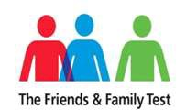**2. EXPERIENCE**

To measure patient and staff experience we ask a number of questions. The idea is simple: if you like using a certain product or doing business with a particular company you like to share this experience with others.

The answers given are used to give a score which is the percentage of patients who responded that they would recommend our service to their friends and family

**Patient Experience**

**The Friends and Family Test**

The Friends and Family Test (FFT) requires all patients to be asked, at periodic points or following discharge, **‘*How likely are you to recommend our ward /A&E /service/organization to friends and family if they needed similar care or treatment?’***

**January 2019**

|  |  |  |
| --- | --- | --- |
| **Clinical location** | **Number of responders** | **% who would recommend** |
| **Inpatient wards (inc. children’s ward)** | 344 | 93.89 % |
| **A&E (SOHT only)** | 28 | 42.85 % |
| **Maternity** | 42 | 85.71 % |
| **Overall Trust \***  **Also includes Children’s A&E)** | 486 | 89.09 % |

*This result may have changed since publication, for the latest score please visit:

[Southport & Formby District General Hospital](https://www.nhs.uk/Services/hospitals/Overview/DefaultView.aspx?id=1412)

[Ormskirk & District General Hospital](https://www.nhs.uk/Services/hospitals/Overview/DefaultView.aspx?id=886)

**3. IMPROVEMENT**

**Improvement story: we are listening to our patients and making changes**

When things do not run smoothly, it is important look at what happened and make improvements.

A patient has shared their experience with members of the Trust Board recently. The patient who was already a patient on one of the hospital wards needed to attend an appointment within one of the Trust Out-patient clinics.

Due to the complex needs of the patient, they were accompanied to the appointment by three members of staff. Unfortunately the patient experienced a delay of an hour and a half. This compromised the success of the appointment and left the ward/dept without key staff for an extended period of time.

On reviewing the patients’ experience it became clear that there was poor communication as there was a lack of awareness by Out-patient staff that the patient was an In-patient at the time of the appointment. There was also a lack of awareness by all staff involved about the patients complex care needs which meant consideration as to whether the patient could be managed safely within a clinic setting was not adequately considered and there was an absence of visual and verbal communication regarding clinic delays.

Learning from this, and in order to support a more positive patient experience for the future we have shared the experience widely with staff and recommended the following:

* Prior to an inpatient attending an out-patient clinic appointment, staff should consider if the patient can be seen by the relevant medical/surgical team within the ward/dept area. If it is necessary for the patient to attend clinic, wards/depts. must alert the relevant clinic that a patient is currently an inpatient in their area and request information regarding any expected clinic delays. It is then the responsibility of the specified clinic to communicate any delays and negotiate a realistic time for the patient to leave the ward/dept to attend to ensure the patient is not delayed and their care needs can be met in an appropriate environment.
* Any supporting information regarding enhanced care needs should be shared between ward/dept and clinic staff so that mutual understanding can be achieved.
* It will be the responsibility of clinic staff to consistently inform patients, carers and families of any delays. This should be presented both visually and verbally to ensure that all patients receive this information in case of visual impairments/hearing loss etc.